ORACLE v1.7
Trade Entry Mockups — 2 April 2026
What Oracle would have done with the Three Session strategy integrated
NQ / MNQ Futures · Asian session range · Level Rejection and Retest model

CONTEXT | These mockups show how Oracle v1.7 would have traded the 2 April 2026 session — the tariff shock day. The actual Oracle v1.5 captured +$300 via the daily target. The proposed v1.7 logic targeting the full Asian session range would have captured an estimated +$5,448 from the same two structural setups.

1 Market Context — 2 April 2026
The 2 April 2026 session was the day after President Trump's 'Liberation Day' tariff announcement. NQ had fallen -433pts overnight. At the London open the market was in an extreme state with the EMA steeply bearish and price well below all key structural levels.

Despite this, the market produced two of the clearest structural setups of the entire forward test period — both defined by the Asian session range established overnight.

Level | Price | Role on 2 April
Asian High | 24,245.75 | Resistance — rejected price twice before flip
Asian Low | 23,752.00 | Support sweep — trigger for the long entry
PDL | 23,880 | Support on the bounce — confirmed level flip
PDH | 24,350 (approx) | Capped the entire day's rally

2 Trade 1 — Asian Low Sweep LONG

2.1 Setup
At approximately 09:45, price swept below the Asian session low at 23,752 — spiking down to approximately 23,710 before snapping back above the level with a large bullish candle. This is the Liquidity Sweep + Return signal that Oracle already recognises, combined with the Asian session low sweep signal from the Three Session strategy v3.

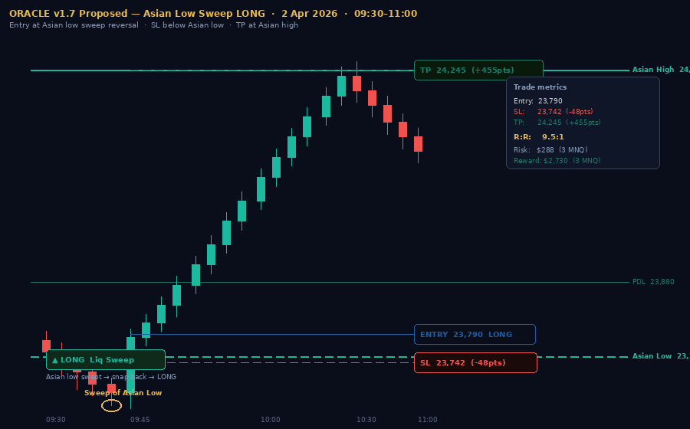

2.2 Entry logic
- Signal type: Liquidity Sweep + Return at Asian session low
- Entry: 23,790 — close of the snap-back candle above the Asian low
- Stop Loss: 23,742 — 10 points below the Asian low sweep extreme
- Take Profit: 24,245 — the Asian session high (structural target)
- Risk: 48 points — $288 at 3 MNQ contracts ($6/point)
- Reward: 455 points — $2,730 at 3 MNQ contracts
- R:R: 9.5:1 — using the Asian high as the structural TP target

2.3 Why this entry is valid
The Asian low is the bottom boundary of the overnight range. When price sweeps below it and immediately snaps back, this indicates that institutional stop-loss orders below the level have been triggered (the liquidity has been swept) and buyers have re-entered strongly. The snap-back candle closing back above the Asian low is the confirmation that the sweep is complete and the reversal is genuine.

Under v1.5, Oracle fired this signal but closed after 20 minutes at +4 points via the duration timer. Under v1.7, the Asian high at 24,245 becomes the structural take profit target — the trade runs to the other boundary of the Asian range.

v1.5 RESULT | Oracle correctly identified this entry and fired the signal. The trade captured +4 points ($24 at 3 MNQ) via the 20-minute duration timer before the move began in earnest.

v1.7 PROPOSED | Same entry. SL below sweep extreme. TP at Asian high. Full move captured: +455 points = +$2,730 at 3 MNQ contracts.

3 Trade 2 — Asian High Rejection SHORT

3.1 Setup
After the long trade reached the Asian high at 24,245, price formed a double-top pattern — two separate tests of the Asian high level within a short window. The first touch (Touch 1) flagged the level as active resistance. The second touch (Touch 2 — the retest) fired the short entry. This is the Rejection and Retest model from v1.6 applied to the Asian session high.

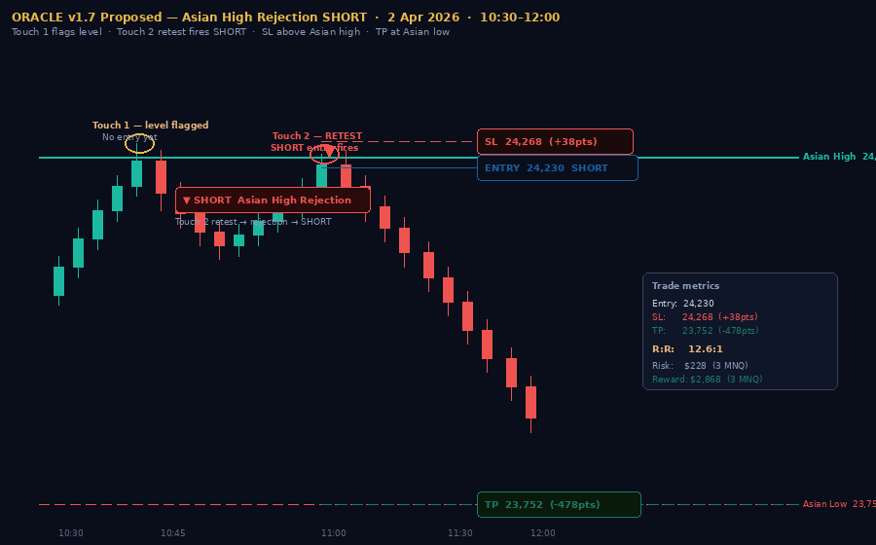

3.2 Entry logic
- Signal type: Asian High Rejection — Touch 1 flags, Touch 2 fires SHORT
- Entry: 24,230 — close of the rejection candle on Touch 2
- Stop Loss: 24,268 — 5 points above the Asian high
- Take Profit: 23,752 — the Asian session low (structural target)
- Risk: 38 points — $228 at 3 MNQ contracts
- Reward: 478 points — $2,868 at 3 MNQ contracts
- R:R: 12.6:1 — using the Asian low as the structural TP target

3.3 Why the two-touch confirmation matters
A single touch of the Asian high could be a breakout — price testing resistance before pushing through. The two-touch confirmation removes this ambiguity. Touch 1 shows that price was rejected at the level. Touch 2 (the retest) confirms that the level is holding as resistance. The second rejection at the same level with the EMA bearish is a high-conviction short entry.

The Asian high at 24,245 is structurally the most important level of the day — it is the exact top of the overnight range that the market had already accepted. Price returning to it from below faces the maximum resistance because all of the participants who were long from the Asian high are now in a position to sell.

v1.5 RESULT | Oracle had no signal here — the daily target had already been hit at 10:30 and the bot had shut down. Even if active, v1.5 has no Asian session high level and no two-touch entry logic.

v1.7 PROPOSED | Short at Touch 2 retest of Asian high. SL above Asian high. TP at Asian low. Full move captured: +478 points = +$2,868 at 3 MNQ contracts.

4 Full Session Overview
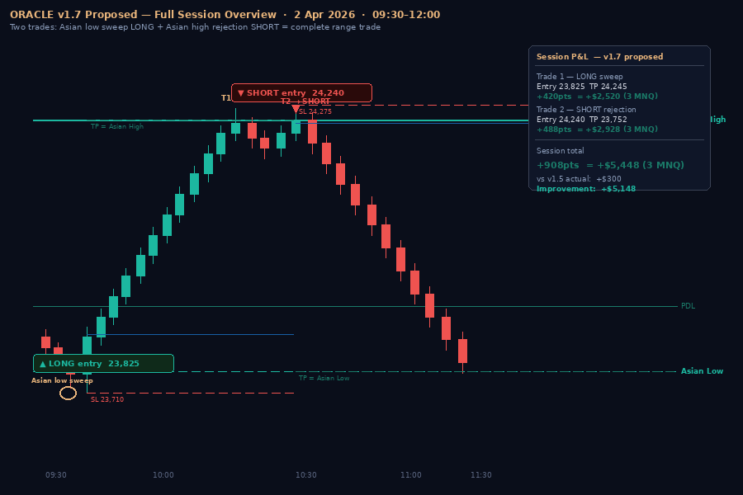

4.1 Session P&L comparison
 | Oracle v1.5 | Oracle v1.7 (proposed) | Difference
Trade 1 — Long | +$24 | +$2,520 | +$2,496 more
Trade 2 — Short | Not taken | +$2,868 | +$2,868 new trade
Daily target fired | +$300 (target) | No limit needed | Target protection less relevant with structural exits
Session total | +$300 | +$5,448 | +$5,148 improvement

4.2 What made this session exceptional
- The Asian session defined the range precisely. The overnight session set a 493-point range (23,752 to 24,245). Every significant move during the London and NY sessions was contained within this range — price swept the low, bounced to the high, and then reversed back.
- Both entries had structural justification. The long entry was a liquidity sweep of the Asian low. The short entry was a two-touch rejection of the Asian high. Both have clear invalidation levels (Asian low for the long, Asian high for the short) that define the stop placement naturally.
- The R:R ratios are exceptional. 9.5:1 on the long and 12.6:1 on the short. These ratios are achievable because the Asian session range provides both the entry signal (the sweep/rejection) and the structural target (the opposite boundary of the range).
- Neither trade required the duration timer. Both trades would have reached their structural targets well within any reasonable time limit. The duration timer — the single biggest issue in v1.5 — becomes irrelevant when the exit is defined by structure rather than time.

4.3 Why this validates the v1.7 development plan
This session is the clearest single evidence case for every major architectural decision in the v1.6 and v1.7 update plans. The level logic is correct — Oracle identified the right entry point. The exit logic needs fixing — the duration timer prevented capturing the move. The Asian session range provides the structural targets that make dynamic exits possible.

# | Update item | Evidence from 2 April
1 | Level Rejection and Retest model | Asian high rejected twice — Touch 1 and Touch 2 clearly visible
1a | Dynamic R:R — SL at structure | SL at Asian low/high provided tight risk. Duration timer was the only constraint.
6 | Duration timer review | Trade 1 captured 4pts of 455pts. Duration timer is the root cause.
20 | Asian session range (v1.7) | Asian range defined the entire session's structure. Both entries used Asian levels.
22 | Asian sweep signals (v1.7) | Asian low sweep at 09:45 was the precise entry point for the long.
23 | FVG signals (v1.7) | Multiple FVGs formed during the rally — additional confirmation opportunities.

Oracle v1.5 actual result: +$300 (daily target) · Oracle v1.7 proposed result: +$5,448 · 2 April 2026
These are proposed trade entries based on the v1.7 logic framework. They are not guaranteed results. They demonstrate the potential improvement from incorporating the Asian session range and structural exit targets into Oracle's signal and exit logic.

