ORACLE
Strategy User Guide
See the level before price arrives
NQ / MNQ Micro E-Mini Nasdaq-100 Futures
TradingView Pine Script v5 · 1-Minute Chart · Version 1.5
Complete Setup, Settings and Strategy Instruction Guide

WHO IS THIS FOR | This guide is written for traders who have been given access to the Oracle strategy on TradingView. It covers everything from initial setup through to daily live trading — including step-by-step TradingView configuration, every setting explained, how to read signals, how to export and analyse trade data, and the complete development roadmap. No coding knowledge required.

Contents  1. What is Oracle?  2. How Oracle Works  3. What Oracle Looks For (with diagrams)  4. TradingView Setup — Step by Step  5. Settings Panel Walkthrough  6. Reading the Chart  7. Recommended Settings Reference  8. How to Set Up Alerts  9. Exporting and Analysing Trades  10. Backtest Performance  11. Risk Management  12. Daily Trading Routine  13. First Week Guide  14. Development Roadmap  15. Post-Testing Update Plan  16. Common Questions | Quick Reference  Stop Loss: 30 points  Take Profit: 20 points  Contracts: 3 MNQ  Daily profit target: $300  Daily loss limit: $700  Weekly target: $1,000  London session: 03:00 – 08:00  NY session: 08:00 – 16:00  Blackout 1: 06:00 – 09:00  Blackout 2: 10:00 – 15:00  Tuesday: OFF  EMA filter: ON (period 50)  Volume filter: ON (100%)  Backtest Mode: OFF — check daily

1 What is Oracle?
Oracle is an automated trading strategy built in Pine Script v5 for TradingView. It is designed specifically for the NQ and MNQ Micro E-Mini Nasdaq-100 futures market on a 1-minute chart.

The core idea is simple: institutional traders and large funds leave footprints at key structural price levels. When price reaches these levels — previous day highs and lows, weekly and monthly extremes, and the previous Friday close — it tends to either reverse or consolidate. Oracle identifies these levels in advance, waits for price to arrive, and then looks for a candlestick signal confirming the reversal before entering a trade.

Oracle is a mean-reversion and level-rejection strategy — not a trend-following strategy. It is most effective in structured, session-driven markets, which is exactly what NQ futures provides during the London and New York sessions.

1.1 The three script versions
Version | File name | Who it is for
Oracle Basic | Oracle_Basic_v1.5 | New users. Advanced settings are hidden and locked. Designed for consistent live trading without configuration risk.
Oracle Pro | Oracle_Pro_v1.5 | Experienced users who want full access to every setting. All options visible and configurable.
Oracle Master | Oracle_Master_v1.5 | Development version. Full access. Used as the source for Basic and Pro. Not recommended for live trading.

2 How Oracle Works
Oracle operates in four stages on every bar of the 1-minute chart.

2.1 Stage 1 — Drawing the key levels
Level | What it is | Why it matters
PDH | Previous Day High | Resistance — sell orders rest here. Oracle looks for short rejections.
PDL | Previous Day Low | Support — buy orders rest here. Oracle looks for long rejections.
PWH / PWL | Previous Week High / Low | Stronger than daily. More orders, larger potential moves.
PMH / PML | Previous Month High / Low | Strongest levels. Institutional orders concentrated here.
Prev Friday Close | Last Friday closing price | Directional — resistance from below, support from above.

2.2 Stage 2 — Level bias
Each level has a directional bias. High levels (PDH/PWH/PMH) only allow short signals. Low levels (PDL/PWL/PML) only allow long signals. The Prev Friday Close direction is determined by which side price approaches from. When price breaks decisively through a level it flips its role — resistance becomes support and vice versa.

2.3 Stage 3 — Signal confirmation
Six candlestick signal types confirm entries: Pin Bar Rejection, Engulfing (Strict), 3-Candle Reversal, Liquidity Sweep + Return, Morning/Evening Star, and Momentum Candle. The more signals that coincide at the same level touch, the higher the entry confidence.

2.4 Stage 4 — Entry gates
All of the following must be true simultaneously before an entry fires: trading session active, correct day of week, no blackout window, daily limits not hit, weekly target not hit, EMA trend filter clear, volume filter met, signal spacing met, no open position.

3 What Oracle Looks For
The three diagrams below illustrate the core concepts behind Oracle's entry logic.

3.1 Level bias — the right direction at the right level
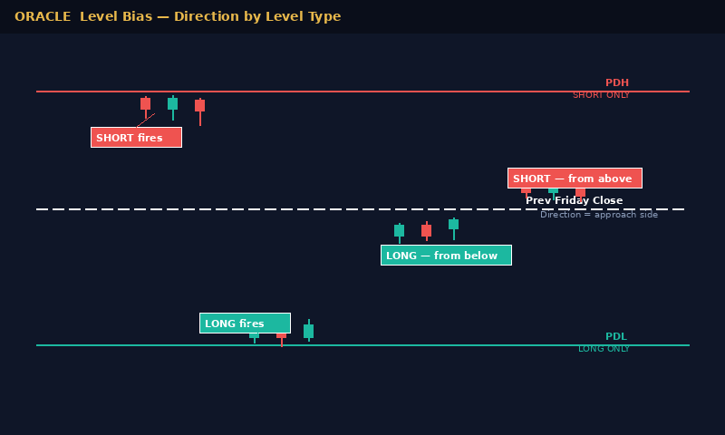
- Red levels (PDH/PWH/PMH): Resistance — short signals only.
- Teal levels (PDL/PWL/PML): Support — long signals only.
- White dashed (Prev Friday Close): Direction determined by which side price approaches from.

3.2 Rejection and retest — the entry pattern
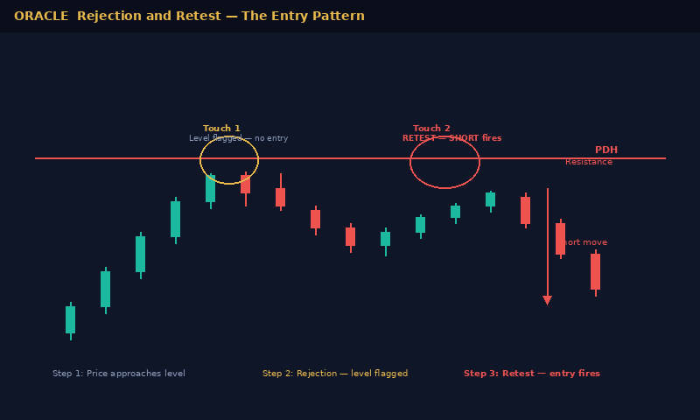
- Touch 1: Price reaches the level, rejection candle forms. Level is flagged as active. Oracle does NOT enter yet.
- Touch 2: Price retests the level within the confirmation window. A confirming candle fires the entry. This is where the signal label appears on the chart.

3.3 Level flip — when resistance becomes support
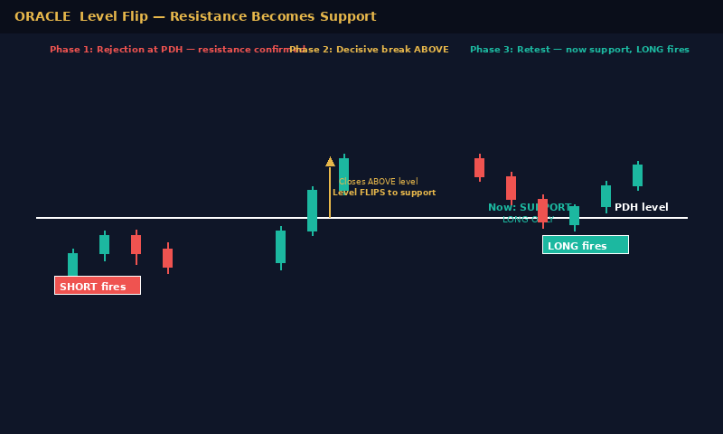
- Phase 1: Rejection at PDH — resistance confirmed, short valid.
- Phase 2: Price closes decisively above PDH — level flips to support.
- Phase 3: Price retests PDH from above — now support, long valid.

4 TradingView Setup — Step by Step
Follow these steps to add Oracle to your TradingView chart for the first time. This process takes approximately 10 minutes.

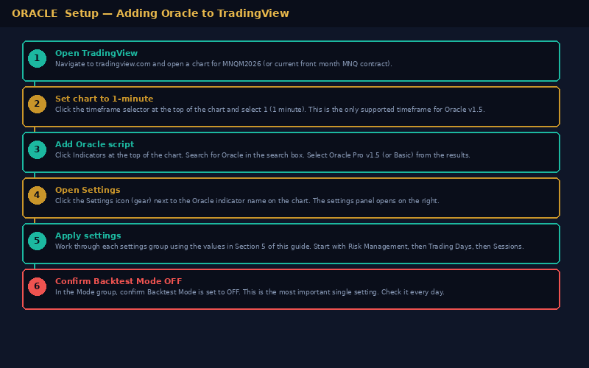

Step 1 | Open TradingView and navigate to your chart  Go to tradingview.com and log in to your account. Open a chart for the MNQ futures symbol — use MNQM2026 or the current front month contract. If you are unsure which contract is current, check the CME Group website for the active MNQ contract.
Step 2 | Set the chart timeframe to 1-minute  Click the timeframe selector at the top of the chart (it will show whatever timeframe is currently active, for example 5 or 15). Click 1 to select the 1-minute timeframe. Oracle v1.5 is designed and optimised for 1-minute bars only.
Step 3 | Add the Oracle script  Click the Indicators button at the top of the chart (or press the / key). In the search box type Oracle. Locate Oracle Pro v1.5 or Oracle Basic v1.5 in the results (shared by the strategy author). Click it to add it to the chart. The key level lines and summary table will appear immediately.
Step 4 | Open the Settings panel  Once Oracle is on the chart, its name appears in the top-left corner of the chart. Click the gear icon (Settings) to the right of the Oracle name. The settings panel opens on the right side of the screen.
Step 5 | Apply the recommended settings  Work through each settings group in order. Use the full settings reference in Section 7 of this guide. Every setting has the exact value to use and an explanation of why. Do not skip any group.
Step 6 | Confirm Backtest Mode is OFF  This is the single most important setting. In the Mode group at the top of the settings panel, confirm Enable Backtest Mode is toggled OFF. If it is ON and you have broker integration active, historical signals will fire as live orders. Check this every single day before the London session opens.
Step 7 | Save and apply  Click OK to close the settings panel. Oracle is now active and scanning. The BOT STATUS banner in the bottom corner of the chart will show the current state.

WHICH VERSION TO USE | Start with Oracle Basic if you are new to the strategy. The Basic version locks and hides advanced settings that could be accidentally misconfigured. Move to Oracle Pro once you are comfortable with how the strategy behaves in live conditions.

5 Settings Panel Walkthrough
The Oracle settings panel is organised into groups. Each group controls a different aspect of the strategy. This section walks through every group in the order they appear in the panel, explaining what each setting does and what value to use.

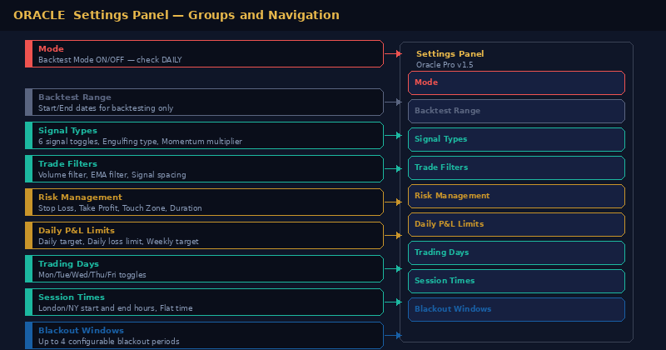

5.1 Mode group
CRITICAL | This is the first group in the settings panel. It contains the most important single setting in the entire strategy.

Setting | Value / Instruction
Enable Backtest Mode | OFF — Must be OFF for live trading. When ON, Oracle replays all historical signals across every bar on the chart.

5.2 Backtest Range group
Only relevant when Backtest Mode is ON. Leave these at their defaults for live trading.
Setting | Value / Instruction
Start Date | 2023-03-12
End Date | 2099-12-31 — far future date covers all live bars

5.3 Signal Types group
Setting | Value / Instruction
Pin Bar Rejection | ON
Bearish/Bullish Engulfing | ON
3-Candle Reversal | ON
Liquidity Sweep + Return | ON
Morning / Evening Star | ON
Momentum Candle | ON
Engulfing Type | Strict — do not change to Relaxed
Momentum Multiplier | 1.5 — minimum body size threshold

5.4 Trade Filters group
Setting | Value / Instruction
Enable Volume Filter | ON
Minimum Volume % | 100 — must equal or exceed 20-bar average
Enable EMA Trend Filter | ON
EMA Period | 50
Min Bars Between Signals | 3 — prevents signal clusters at same level

5.5 Risk Management group
IMPORTANT | The Stop Loss was set at 50pts in Week 1 and 40pts in Week 2 of live testing. It is reverting to 30pts from Week 3. Always confirm the SL is set to 30pts before each session.

Setting | Value / Instruction
Stop Loss | 30 points — $180 per trade at 3 MNQ contracts
Take Profit | 20 points — $120 per trade at 3 MNQ contracts
Level Touch Zone | 8 points — how close price must be to qualify as a level touch
Stop Loss Type | Fixed — do not switch to ATR
Enable Max Trade Duration | ON
Max Trade Duration | 20 minutes — hardcoded in Basic, configurable in Pro
Starting Contracts | 3 MNQ — do not increase until 4+ weeks of live data collected

5.6 Daily P&L Limits group
Setting | Value / Instruction
Enable Daily Profit Target | ON
Daily Profit Target | $300 — Oracle stops trading for the day when this is hit
Enable Daily Loss Limit | ON
Daily Max Loss | $700 — hard stop. No more trades today.
Enable Weekly Profit Target | ON
Weekly Profit Target | $1,000 — conservative starting point
Consecutive Loss Alert | ON — alert threshold: 2 consecutive losses
Enable London Session Loss Limit | OFF — scheduled for removal in v1.6
Enable NY Session Loss Limit | OFF — scheduled for removal in v1.6

5.7 Trading Days group
Setting | Value / Instruction
Monday | ON
Tuesday | OFF — consistently worst day across all backtests. Leave disabled.
Wednesday | ON
Thursday | ON — best performing day (72.7% WR in backtest)
Friday | ON

5.8 Session Times group
Setting | Value / Instruction
Chart Timezone | America/New York — or Exchange. Must match your broker timezone.
London Session Start | 03:00
London Session End | 08:00
New York Session Start | 08:00
New York Session End | 16:00
Flat Time Start | 17:00 — closes all open positions
Flat Time End | 17:59

5.9 Blackout Windows group
Blackout windows block trading during known low-quality periods. Two blackouts are active by default.
Setting | Value / Instruction
Blackout 1 | ON — 06:00 to 09:00. Eliminates weak pre-market London hours.
Blackout 2 | ON — 10:00 to 15:00. Eliminates losing NY afternoon hours.
Blackout 3 | OFF
Blackout 4 | OFF

6 Reading the Chart

6.1 Key level lines
Setting | Value / Instruction
Red horizontal line | Previous Day High (PDH) — resistance
Teal horizontal line | Previous Day Low (PDL) — support
Blue horizontal line | Previous Week High / Low
Orange horizontal line | Previous Month High / Low
White horizontal line | Previous Friday Close

6.2 Signal labels and markers
Setting | Value / Instruction
Red label — SHORT | Short entry fired. Shows signal type(s) that triggered it.
Green label — LONG | Long entry fired. Shows signal type(s) that triggered it.
Downward arrow (exit) | Trade closed — at Take Profit, Stop Loss, or max duration.
+N on exit | Points captured on the trade.
-N on exit | Points lost on the trade.
Max duration label | Trade closed because 20-minute limit was reached.

6.3 Summary dashboard table
Row | What it shows
BOT STATUS | Current state: Active (scanning), In trade, Daily target hit, Daily loss limit hit, Blackout active, Day off, or Weekly target hit.
London / New York | Trades taken and P&L attributed to each session. Status shows Active, Closed, Blackout, or Day off.
Week | Total trades and cumulative P&L for the current Monday-to-Friday week. Survives chart reloads.
R:R Ratio | Current risk to reward based on TP and SL settings. Shows TP points / SL points.
Streak | Current consecutive win or loss streak. Fires alert when threshold is reached.
Annual | Year-to-date P&L against annual target. Shows percentage achieved and pro-rata pace.
Req. contracts | Estimated contracts to hit annual target based on win rate projection. A guide only.

7 Recommended Settings Reference
Complete reference table. All values derived from Run 4 backtest (12 months, 136 trades, 66.9% WR, 1.731 PF).

DO NOT CHANGE | These settings are locked in for the 4-week forward test. No changes until the CSV data is reviewed after 19 April 2026.

Setting | Value | Why
All 6 signals | ON | All signal types contribute unique entries. Disabling any reduces trade count.
Engulfing — Strict mode | ON | Relaxed mode generates false signals at levels with small bodies.
Momentum multiplier | 1.5x | Below 1.5 generates noise candles. Above 2.0 misses valid entries.
Volume filter | ON at 100% | Low-volume signals at levels have poor follow-through.
EMA filter | ON at 50 | Prevents counter-trend entries. 50 period is optimal for 1-min NQ.
Signal spacing | 3 bars | Prevents entering multiple times on same level move.
Stop Loss | 30 pts | Covers normal level volatility without being too wide.
Take Profit | 20 pts | Achievable in most session conditions within 20 min.
Touch zone | 8 pts | Wide enough for realistic level touches, tight enough to avoid noise.
Duration | 20 mins | Closes choppy trades before they reverse. 20 bars on 1-min.
Contracts | 3 MNQ | $6/pt. Meaningful returns with controlled per-trade risk.
Daily profit | $300 | Protects winning days. Bot shuts down automatically.
Daily loss | $700 | Less than 4 full stop losses. Prevents catastrophic days.
Weekly target | $1,000 | Conservative. Equivalent to ~8 winning trades.
Tuesday | OFF | Eliminated across all 4 backtests — persistent underperformer.
London | 03:00-08:00 | Deep London session — highest quality level reactions.
NY | 08:00-16:00 | Extended to 16:00 in Run 4 — captured profitable 15:00 window.
Blackout 1 | 06:00-09:00 | Pre-market London — choppy, low conviction level touches.
Blackout 2 | 10:00-15:00 | NY afternoon — consistently the worst performing window.

8 How to Set Up Alerts
Oracle fires alerts when signals fire, when daily limits are hit, and when the consecutive loss threshold is reached. Setting up alerts means you receive notifications on your phone or email without needing to watch the chart continuously.

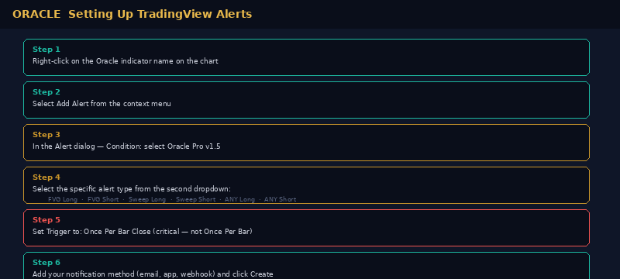

Step 1 | Right-click on the Oracle indicator name  On the chart, locate the Oracle Pro v1.5 label in the top-left corner. Right-click on it to open the context menu.
Step 2 | Select Add Alert  In the context menu, click Add Alert. The TradingView Alert dialog opens.
Step 3 | Set the Condition  In the first dropdown, select Oracle Pro v1.5 (or Oracle Basic v1.5). In the second dropdown, select the specific alert type you want.
Step 4 | Choose your alert type  Available alert types: FVG Long, FVG Short, Sweep Long, Sweep Short, ANY Long Signal, ANY Short Signal. Create a separate alert for each type you want to receive.
Step 5 | Set Trigger to Once Per Bar Close  This is critical. In the Trigger section, select Once Per Bar Close. Do not use Once Per Bar — it will fire multiple times on the same bar and create noise.
Step 6 | Add your notification method  Select your preferred notification — email, push notification to the TradingView mobile app, SMS, or webhook. Enter your details and click Create.
Step 7 | Repeat for each alert type  Create one alert for ANY Long Signal and one for ANY Short Signal as a minimum. This covers all entry signals in a single alert each.

WEBHOOK ALERTS | If you are using PineConnector or a similar broker integration for automated execution, use the webhook notification type and paste your PineConnector webhook URL into the Webhook URL field. The alert message format is already configured in Oracle's alert() calls.

9 Exporting and Analysing Trades

9.1 Exporting from TradingView Strategy Tester
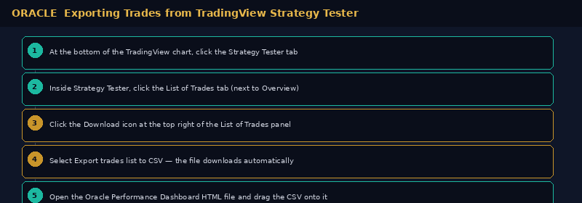

Step 1 | Open Strategy Tester  At the bottom of the TradingView chart, click the Strategy Tester tab. If it is not visible, click the panel icon at the bottom of the screen.
Step 2 | Click List of Trades  Inside Strategy Tester, click the List of Trades tab (next to Overview and Performance Summary). This shows every individual trade with entry and exit details.
Step 3 | Click the Download icon  At the top right corner of the List of Trades panel, click the Download icon (downward arrow). A dropdown appears with export options.
Step 4 | Select Export trades list to CSV  Click this option. A CSV file downloads automatically to your default downloads folder. The filename includes the symbol and date range.
Step 5 | Load into the Oracle Performance Dashboard  Open Oracle_Performance_Dashboard.html in your browser. Drag and drop the CSV file onto the dashboard, or click Load CSV in the header. Your performance data loads instantly.

9.2 Using the Oracle Performance Dashboard
The dashboard is a standalone HTML file that runs entirely in your browser. No installation, no account, no data uploaded anywhere.

Tab / Feature | What it shows
Header metrics | Five summary cards: Total P&L, Win Rate, Profit Factor, Avg Win/Loss, Max Drawdown.
Overview tab | Equity curve, daily P&L bar chart, P&L by day of week, P&L by hour, exit signal breakdown.
Trade Log tab | Scrollable table of every trade — entry/exit time and price, direction, points, P&L, cumulative P&L, signal type.
Breakdown tab | Performance tables by day of week, hour of day, direction (long vs short), exit type.
Lock system | PIN-based lock to enforce daily loss limits. Lock button in the header. Auto-unlocks at midnight.
Loading multiple files | Drop multiple CSVs or JSON files at once — they merge into one combined dataset automatically.
Reset | Click Reset in the header to clear all loaded data and start fresh.

9.3 Dashboard Lock System
- Setting up your PIN: Click the red Lock button in the dashboard header (visible once data is loaded). Enter a 4–6 digit PIN and confirm.
- Activating the lock: When Oracle fires a daily loss limit alert, open the dashboard and click Lock. The overlay activates immediately with a countdown to midnight.
- Auto-unlock: The lock releases automatically at midnight. A new trading day begins cleanly.
- Override: Enter your PIN to unlock early. Every override is logged with a timestamp and a warning banner is displayed for the rest of the session.

10 Backtest Performance
Run 4 results — 21 March 2025 to 21 March 2026, MNQM2026, 3 MNQ contracts, 1-minute chart.

DISCLAIMER | Past backtest performance does not guarantee future results. These figures show historical characteristics. Live trading results will differ.

Metric | Value | Metric | Value
Total P&L | +$4,825.50 | Total trades | 136
Win rate | 66.9% | Max drawdown | $831 (0.08%)
Profit factor | 1.731 | Avg win | +$125.50
Long P&L | +$3,198.00 | Short P&L | +$1,627.50
Best day | Thursday 72.7% WR | Avg loss | -$146.60

11 Risk Management

11.1 Trade level
- Stop Loss (30pts): $180 per trade at 3 MNQ. Tick-level execution closes at the stop price intra-bar.
- Take Profit (20pts): $120 per trade at 3 MNQ. The R:R is 0.67:1 — compensated by a 65%+ win rate.
- Max duration (20 min): Any trade open longer than 20 minutes closes regardless of P&L.

11.2 Session and week level
- Daily profit target ($300): Oracle stops trading for the day. A good day is banked.
- Daily loss limit ($700): Oracle stops trading for the day. Prevents catastrophic losses.
- Weekly profit target ($1,000): Oracle stops for the week. A strong week is protected.

11.3 Contract scaling
Contracts | $/point | Max SL cost | Condition
3 MNQ | $6 | -$180 | Start here — complete 4 weeks live before scaling
4 MNQ | $8 | -$240 | 4 weeks live, profit factor above 1.5
5 MNQ | $10 | -$300 | 8 weeks live, consistent with backtest monthly profile
6 MNQ | $12 | -$360 | Annual calculator suggests 6 contracts for $30,000/yr

12 Daily Trading Routine

12.1 Pre-session checklist — complete by 02:45 every morning
 | Pre-session checklist
o | Backtest Mode is set to OFF — check this first, every single day
o | Chart is on the correct symbol (front month MNQ contract)
o | Chart timeframe is 1-minute
o | Contract quantity is correctly set in TradingView Properties tab
o | Daily Profit Target is set to $300
o | Daily Loss Limit is set to $700
o | Weekly Profit Target is set to $1,000
o | Blackout 1 is ON (06:00-09:00) and Blackout 2 is ON (10:00-15:00)
o | Tuesday is disabled in Trading Days
o | Backtest Mode is OFF — check this again before you do anything else

12.2 During the session
- Monitor BOT STATUS: The banner shows whether Oracle is active, in a blackout, or has hit a limit. If it shows anything other than Active or In trade, do not try to intervene.
- Do not override signals: If Oracle is not firing, the gates are blocking for a reason — session timing, blackout, daily limit, or no qualifying pattern.
- Consecutive loss alert: When two losses fire in a row, take a moment to review chart context before the next trade.

12.3 End of session
- Export the trade list: Strategy Tester → List of Trades → Export CSV. Do this every day to build your data history.
- Load into the dashboard: Drag the CSV onto the Oracle Performance Dashboard to review the session metrics.
- Note unusual behaviour: If signals fired at unexpected times or in unexpected directions, screenshot the chart with the time visible and note it for the post-testing review.

13 First Week Guide
Your first week of live trading is about observation and data collection — not making changes. This section tells you exactly what to expect and what to do (and not do) in the first seven days.

13.1 What to expect
- All exits at ±3-4 points: This is normal in the first week. The 20-minute duration timer is closing trades before the TP or SL is reached. This is a known issue being reviewed for v1.6. Do not change the duration setting.
- Daily loss limit firing: If the market is trending strongly, counter-trend longs or shorts may fire and hit the daily loss limit. The EMA filter does not always block these in v1.5. This is the highest priority fix in v1.6.
- Signals firing in clusters: Multiple signals at the same level within a few bars is possible in v1.5. The signal spacing of 3 bars (3 minutes on 1-min chart) is the minimum — it does not prevent all clustering.
- Dashboard vs Strategy Tester discrepancy: The dashboard reads from your CSV export. The Strategy Tester shows the currently selected date range. Both are correct — they measure different windows.

13.2 What to do
- Day 1-3: Follow the daily checklist exactly. Do not change any settings. Export the trade list every day. Note any observations in a log.
- Day 4-5: Review the first week's exported CSV in the dashboard. Look at which days and hours are performing well and which are not.
- Day 6-7: Screenshot any chart patterns that seem significant — particularly level rejections, retests and flips. These become evidence for the v1.6 update.

13.3 What NOT to do
- Do not change the SL or TP: The Run 4 settings are the evidence base. Changing them in Week 1 invalidates the forward test.
- Do not disable signals: All 6 signals are ON for a reason. Disabling one because it lost does not mean it will continue to lose.
- Do not turn Backtest Mode ON: If you want to review historical signals, do it on a separate chart. Never turn Backtest Mode ON on your live chart.
- Do not scale contracts: Stay at 3 MNQ for the full 4-week test. No exceptions.
- Do not give back a target week: When the weekly target fires and Oracle shuts down, leave it shut down. Do not manually place trades to try to make more.

14 Development Roadmap
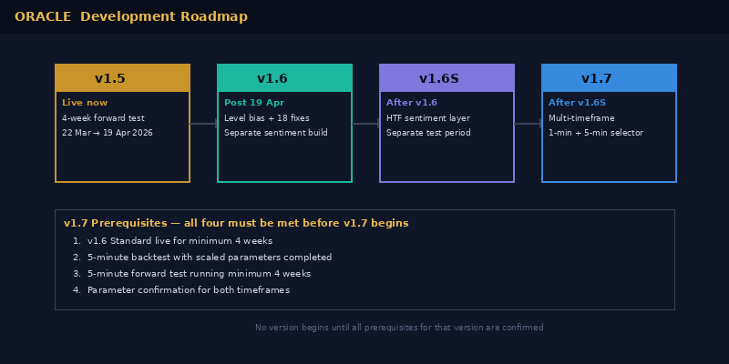

Version | Timeline | Focus | Prerequisites
v1.5 | Live now | 4-week forward test — 22 Mar to 19 Apr 2026 | None — current production version
v1.6 Standard | Post 19 Apr 2026 | Level bias, 18-item update list, bug fixes, removals | 4-week CSV data from v1.5 delivered
v1.6 Sentiment | After v1.6 baseline | HTF sentiment indicator — selectable 5m/15m/30m/1H/2H/3H/4H/Daily | v1.6 Standard live and stable 4+ weeks
v1.7 | Q3 2026 (est.) | Asian/London session ranges, FVG signals, cascading session bias, multi-timeframe — full merge with NQ Three Session Strategy v3 | All 4 prerequisites met: v1.6 live 4wks, 5-min backtest done, 5-min forward test 4wks, parameters confirmed

15 Post-Testing Update Plan — v1.6
The following 18 items are scheduled for implementation in v1.6 after 19 April 2026. Listed in priority order.

# | Priority | Item and detail
1 | CRITICAL | Level Rejection and Retest model with Flip Detection — level bias per type, two-touch entry, flip detection, dynamic R:R (SL at structure, TP = 2x risk). Applies to all 8 level types.
2 | HIGH | EMA filter — add slope direction check. May be partially resolved by Item 1.
3 | HIGH | Signals firing outside session hours (19:00-20:30 UTC-4) — isTradingSession gate fix.
4 | MEDIUM | Incorrect alerts at level touches — bar close proximity check on level touch detection.
5 | MEDIUM | Tuesday signals appearing when disabled — confirm and fix.
6 | MEDIUM | Duration timer vs TP — review whether level touch zone is too wide allowing weak touches.
7 | MEDIUM | Signal spacing — consider increasing from 3 bars to 5+ bars.
8 | LOW | Blackout 2 start time — consider 11:00 instead of 10:00 (31 Mar case).
9 | LOW | Remove Partial Close — not required with tight 20pt TP.
10 | LOW | Remove London Session Loss Limit.
11 | LOW | Remove NY Session Loss Limit.
12 | MEDIUM | Add Monthly P&L to Performance Dashboard — breakdown table and bar chart.
13 | MEDIUM | Add live trade management lines — entry/SL/TP/trail lines and live P&L label, draw on entry delete on exit.

16 Common Questions

Why is Oracle not firing any signals?
Check the BOT STATUS banner. The most common reasons are: Backtest Mode is ON (turn it OFF), you are outside the session window, a blackout is active, the daily limit has been hit, or there are simply no qualifying signal patterns at the current levels. Oracle is selective by design.

Why did Oracle fire a trade I would not have taken?
Oracle applies its rules mechanically without reference to news, sentiment, or broader context. If a signal pattern formed at a key level with all gates open, Oracle fires. This consistency removes emotional bias — which is a feature, not a limitation.

Why is the dashboard showing different P&L to TradingView?
The dashboard reads from CSV exports and shows cumulative P&L across all loaded files. The Strategy Tester shows P&L for the currently selected date range. Both are correct — they measure different time windows. Ensure the TradingView date range matches the period you exported.

Can I run Oracle on a 5-minute chart?
Oracle v1.5 is built and optimised for the 1-minute chart only. Running it on a 5-minute chart changes how every signal, duration, and level touch calculation behaves. Multi-timeframe support is planned for v1.7 with its own optimised parameter set. Until then, use only the 1-minute chart.

Can I change the settings?
The settings in Section 7 are the recommended starting point based on 12 months of backtesting. In Oracle Basic, many advanced settings are locked. In Oracle Pro, everything is accessible. Do not change core settings (SL, TP, session times, blackouts) during your first 4 weeks. After that, all changes must be driven by data from your live trading.

What contract size should I start with?
3 MNQ contracts. A full stop loss costs $180. A full take profit earns $120. Large enough for meaningful returns, small enough that a daily loss limit ($700) does not cause serious account damage. Scale only after 4 weeks of profitable live data.

What if the weekly target is hit early in the week?
Oracle stops trading automatically. The week's profit is banked. Do not override this manually. One of the most common mistakes in trading is giving back a strong week by continuing to trade when it is not necessary.

Why is my R:R showing 0.5:1 or 0.4:1?
The SL was set to 50pts in Week 1 and 40pts in Week 2 of live testing while it was being calibrated. The target is 30pts SL / 20pts TP which gives a 0.67:1 R:R. Confirm the SL is set to 30pts in the Risk Management settings group. The v1.6 update will introduce dynamic R:R which improves this to 2:1.

Oracle v1.5 · User Guide v3 · NQ/MNQ Futures · TradingView Pine Script v5 · April 2026
This document is for users who have been granted access to the Oracle strategy. Trading futures involves substantial risk of loss. Past performance is not indicative of future results. Always trade with capital you can afford to lose.
This document is updated with every strategy version release, settings change, and new pattern identified during live testing.

